Weka Simple Tutorial

1. Welcome GUI

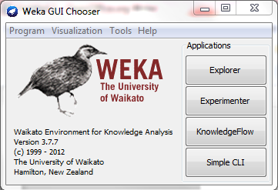
Choose the “Explorer” option. “Experimenter” is used to quickly make many trees, but as a result does not provide as much information.

2. You should then see the following screen.

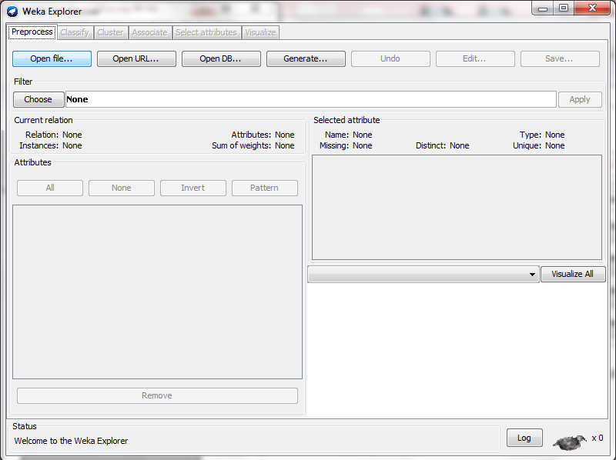

3. Use the “Open file...” button to load the file you want to work with.

By default, an ARFF file is the destination for the results output.
But you can choose between
• ARFF file
• CSV file (Suggested)
Make sure save your input as correct input file format.

When you load a file, you should see something like this:
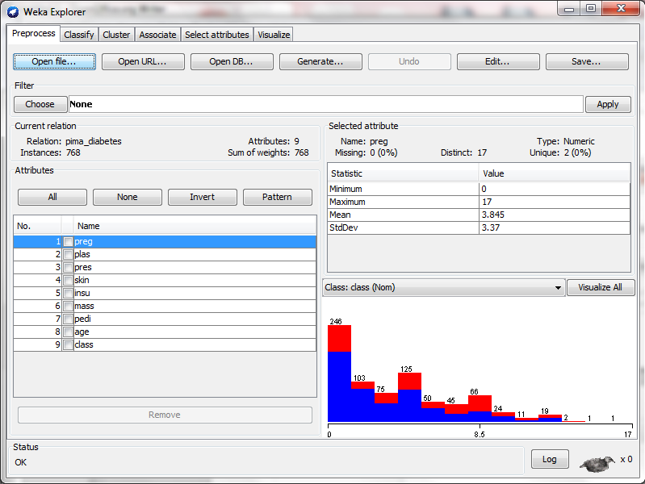

4. To use preprocessing on the dataset, click on the “Choose” button on the left and select a function.

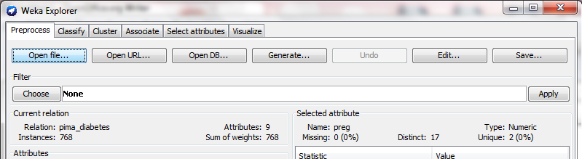

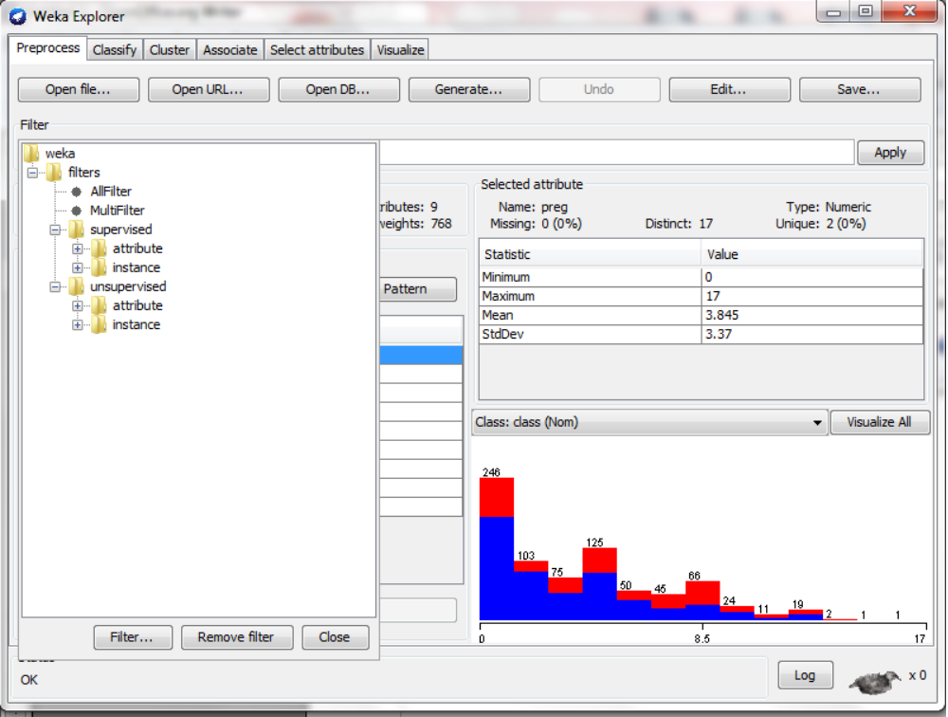

Most of these functions will have options for customization.
These can be selected by clicking on the their textbox, which will pop up a GUI.
Remainder: never forget transform your class label from numeric to nominal.

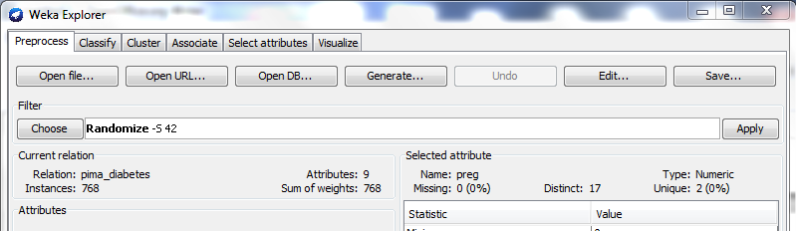
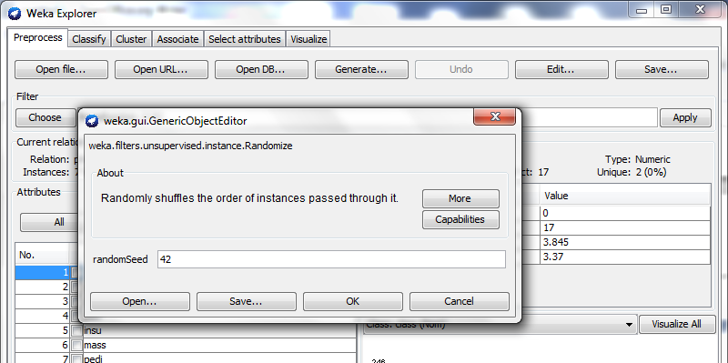
5. To use J48, click on the “Classify” tab at the top.

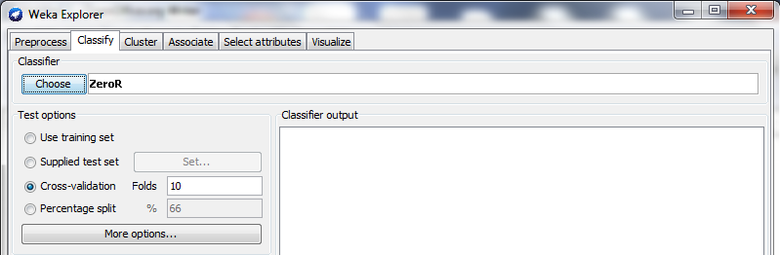

Click the “Choose” button, and select the “J48” option, located under “trees”. Its options can be accessed by clicking on the textbox, as before.

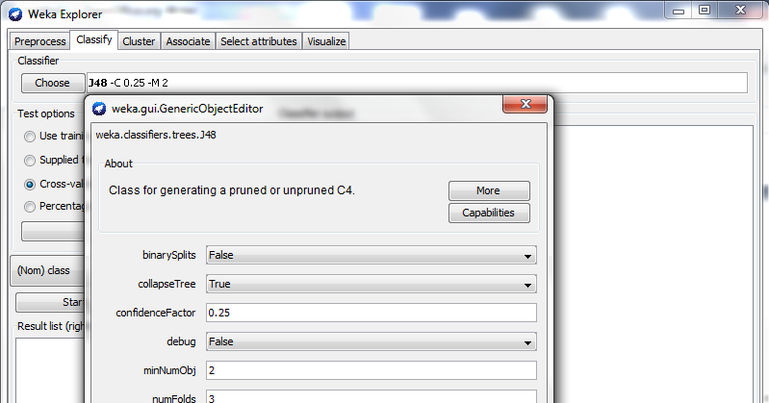
6. To build a tree, select the testing method you want, from the options located at the left, make sure the correct attribute is selected for the classifier, and then press the “Start” button.

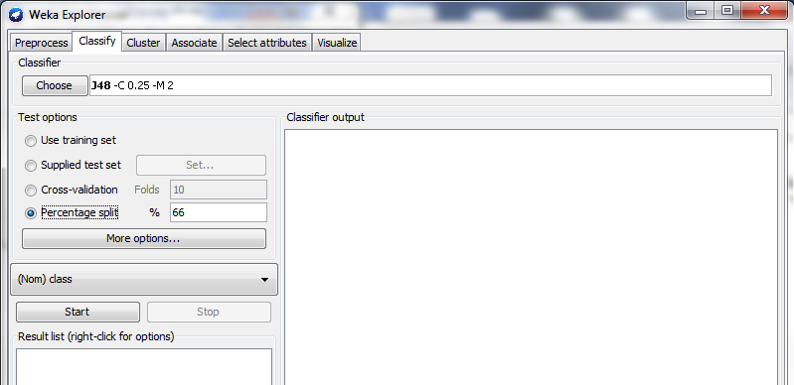
Testing selection
Label selection

7. The results will be shown in the box to the right. In the bottom left box, the model ID will be shown.
Right-click it to access options, such as “Save model”, “Visualize tree”, and “Re-evaluate model on current test set”.

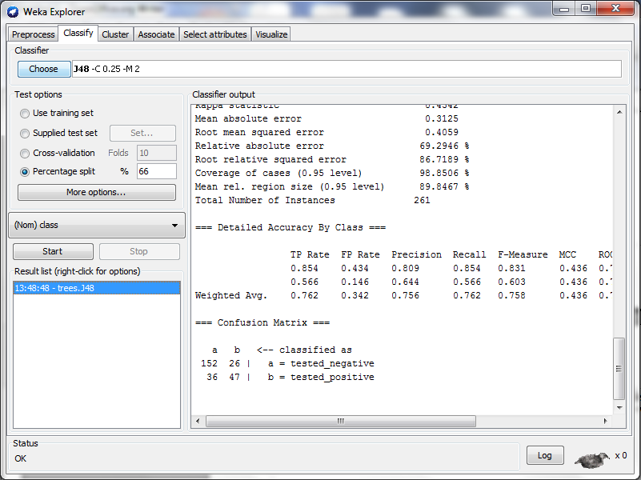
Right-click to access
tree options

- The “Re-evaluate model on current test set” option is useful for comparing the performance of different trees on the same test set.
- You need to save model and submit this model. All evaluation is done over submitted model.


Evaluation Section
- Dataset: other 1000 board states for connect-4 game
- Procedure:
  - Use your submitted program to generate your defined features
  - Features+ class label → Test Data Set
  - Load your submitted model then re-evaluate model on Test Data Set.

